**Topic:** Airline Management System.

|  |  |
| --- | --- |
| Name | ID |
| HOSSAIN, MD. MOBARAK | 18-38054-2 |
| RASEL, MD. | 18-37990-2 |
| SAMS, A.B.M. TOUFIQUL ALAM | 19-39297-1 |
| TAHMID, AKIB | 19-39309-1 |

**Contents: page:**

**Introduction------------------------------------------------------------------------ 3**

**ER Diagram------------------------------------------------------------------------- 4**

**Normalization---------------------------------------------------------------------- 5**

**Table creation---------------------------------------------------------------------- 6**

**Insertion----------------------------------------------------------------------------- 13**

**Constraint--------------------------------------------------------------------------- 17**

**Query question-------------------------------------------------------------------- 21**

**Relational Algebra---------------------------------------------------------------- 22**

INTRODUCTION

1 PROJECT OVERVIEW

In our project we have worked with an airline management system. The main feature of our project is covering online ticket management, booking, flight tracking also we have all the employee’s information in the system. We have all the passenger’s information, all the information about our flight, where the flight will go what stoppage it have. One passenger will be able to book one seat, many booking will have one flight and one flight will have one airplane. Many employee will serve one plane and the employee will mange the booking system.

2. The things we have

We have 5 Entity set, 5 Relationship and lots of Attributes. In the Entity named Management there are 5 attributes. In those attributes there is an attribute name P_email that is multivalued attribute. The P_name attribute is composite attribute and last name and first name are the component of this. P_id is the key attribute. Other two attributes are Nationality and passport-no.  
This Entity will collect the all information of a passenger.

With this Entity Booking Entity is connected by sets named relationship. By this booking Entity passenger can book their seat.Here is also 5 attributes. Booking_id is the key attributes and price, Booking_date, seat-no,class are other 4 attributes.

Booking is connected with two other entity. One of them is Flight and it is connected by assign relationship. Flight Entity has six attributes. Flight-no is the key and Destination, Departure time, Route duration, stoppage are the other attribute. Layover1 and layover2 are two component of stoppage composite attribute. Flight entity will give the information of that particular flight.

Airplane Entity with two attribute A-id and type is connected with Flight Entity bye has relationship. A-id is the key attribute. Air Entity will describe about that air plane.

Serve relationship connect Management entity and airplane. The Management has the most attribute. There are seven attributes in this entity. E-id is the key attribute and E-name, Address are the composite attribute. Street, city, country are the component of the address composite attribute and first name, last names are the component of the name composite attribute. Phone is the multivalued attribute. Job, salary, Hire dates are the other three attributes. This management entity is connected with booking entity by manage relationship. This entity is for the management department. Here all the information of management department job holders will be maintained.

**ER Diagram:**

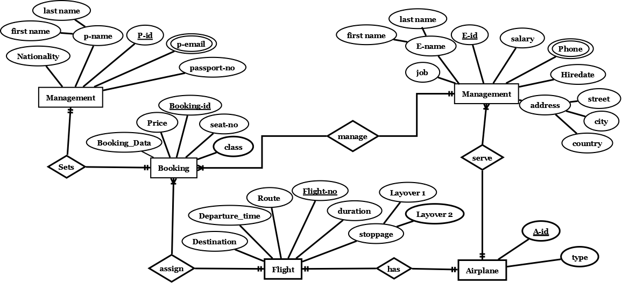

**NORMALIZATION:**

**Relation name: Sets**

**Attributes:** P_id,P_name,P_email,Nationality,Passport_no,Booking_id,

Booking_date, Class_name,Price,Seat_no.

**1NF**: P_email is a multivalued attribute.

**2NF**: P_id ,P_name,P_email,Nationality,Passport_no.

Booking_id, Booking_date, Class_name,Price,Seat_no.

**3NF:** P_id ,P_name,P_email,Nationality,Passport_no **.**

Booking_id , Booking_date ,Seat_no.

Cp_id ,Class_name,Price.

**Total Table List:**

1. P_id ,P_name,Nationality,Passport_no
2. P_id,P_name (Composite primary key).

P_id, P_email

1. Booking_id , Booking_date ,seat_no,
2. Cp_id ,Class_name,Price.

**Relation name: Assign**

**Attributes:** Booking_id ,Booking_date ,Class_name,Price,Seat_no,

Flight_no, Route,Departure_time,Duration,Destination,stoppage.

**1NF:** No multivalued attributes.

**2NF:** Booking_id , Booking_date, Class_name,Price,Seat_no.

Flight_no ,Route,Departure_time,Duration,Destination,stoppage.

**3NF:** Booking_id , Booking_date ,Seat_no.

Cp_id ,Class_name,Price.

Flight_no , Departure_time.

R_id , Route,Duration.

S_id ,stoppage,Destination.

**Total Table List:**

1. Booking_id, Booking_date ,Seat_no,
2. Cp_id ,Class_name,Price.
3. Flight_no , Departure_time,
4. R_id , Route,Duration.
5. S_id ,stoppage,Destination.

**Relation name: Has**

**Attributes:** Flight_no, Route,Departure_time,Duration,Destination,stoppage,A_id, Type.

**1NF:** No multivalued attributes.

**2NF:** Flight_no,Route,Departure_time,Duration,Destination,stoppage.

A_id, Type.

**3NF:** Flight_no,Departure_time.

R_id,Route,Duration.

S_id,stoppage,Destination.

A_id,Type.

**Total Table List:**

1. Flight_no,Departure_time,
2. R_id,Route,Duration.
3. S_id,stoppage,Destination.
4. A_id,Type,

**Relation name: Serve**

**Attributes:** E_id ,E_name,Address,Salary,Hiredate,Job,Ephone,A_id , Type.

**1NF:** Ephone is a multivalued attribute.

**2NF:** E_id ,E_name,Address,Salary,Hiredate,Job,Ephone.

A_id , Type.

**3NF:** E_id ,E_name,Hiredate,Ephone.

J_id ,Job,Salary.

Ad_id ,Street,City,Country.

A_id , Type.

**Total Table List:**

1. E_id ,E_name,Hiredate,
2. E_id,Ephone (Composite primary key).

E_id,Ephone

1. J_id ,Job,Salary.
2. A_id , Type.
3. Ad_id ,Street,City,Country.

**Relation name: Manage**

**Attributes:** E_id ,E_name,Address,Salary,Hiredate,Job,Ephone, Booking_id , Booking_date, Class_name,Price,Seat_no.

**1NF:** Ephone is a multivalued attribute.

**2NF:** E_id ,E_name,Address,Salary,Hiredate,Job,Ephone.

Booking_id , Booking_date, Class_name,Price,Seat_no.

**3NF:** E_id ,E_name,Hiredate,Ephone.

J_id ,Job,Salary.

Ad_id ,Street,City,Country.

Booking_id , Booking_date ,Seat_no.

Cp_id ,Class_name,Price.

**Total Table List:**

1. E_id ,E_name,Hiredate,

**2.** (Composite primary key).

E_id,Ephone

1. J_id ,Job,Salary.
2. Booking_id, Booking_date ,seat_no,
3. Cp_id ,Class_name,Price.
4. Ad_id ,Street,City,Country

**Final Table List:**

|  |  |  |
| --- | --- | --- |
| **Table No** | **Table Name** | **Column Name** |
| **01** | **Passenger** | **P_id**,  **P_name,Nationality,Passport_no,** |
| **02** | **Passenger_1** | **(Composite primary key).**  **P_id,P_email** |
| **03** | **Booking** | **Booking_id Booking_date,seat_no,** |
| **04** | **Booking_1** | **Cp_id ,Class_name,Price.** |
| **O5** | **Flight** | **Flight_no , Departure_time,** |
| **06** | **Flight_1** | **R_id , Route,Duration.** |
| **07** | **Flight_2** | **S_id ,stoppage,Destination.** |
| **08** | **Airplane** | **A_id , Type,** |
| **09** | **Management** | **E_id ,E_name,Hiredate,** |
| **10** | **Management_1** | **(Composite primary key).**  **E_id,Ephone** |
| **11** | **Management_2** | **J_id ,Job,Salary**. |
| **12** | **Address** | **Ad_id ,Street,City,Country.** |

**Table Creation:**

Passenger:

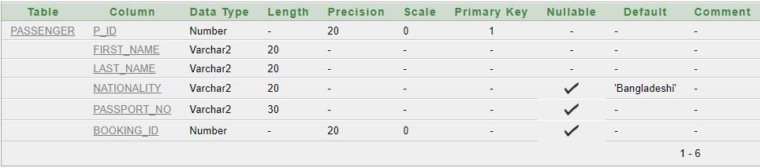

Passenger _1:

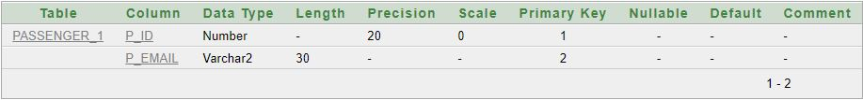

Booking:

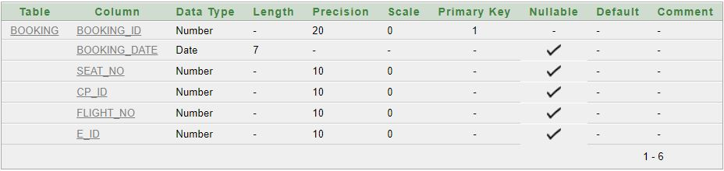

Booking_1:

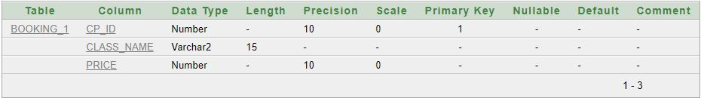

Flight:

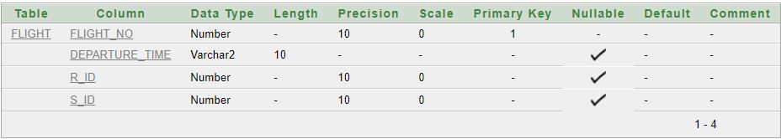

Flight_1:

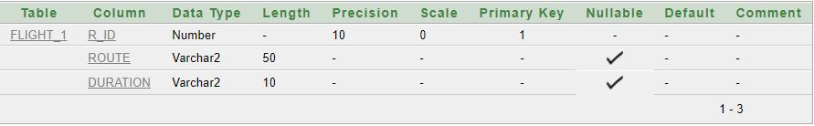

Flight_2:

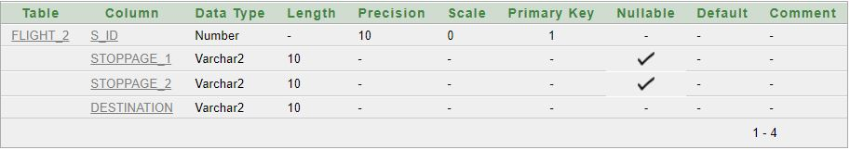

Airplane:

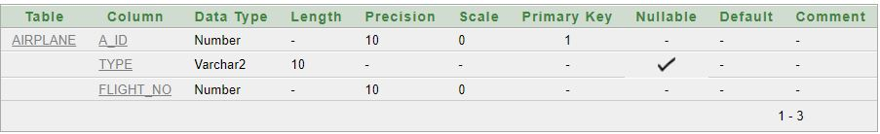

Management:

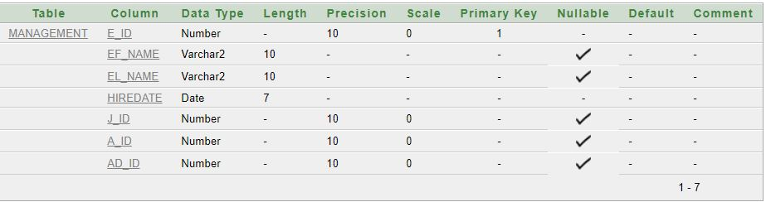

Management_1:

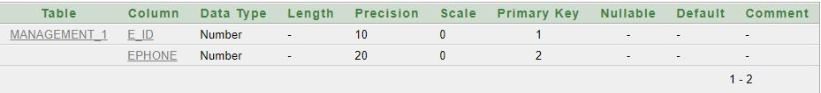

Management_2:

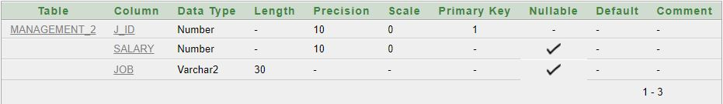

Address:

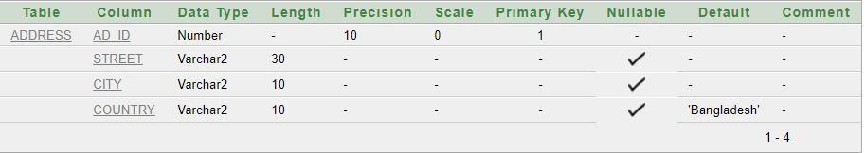

**Value Insertion:**

Passenger:

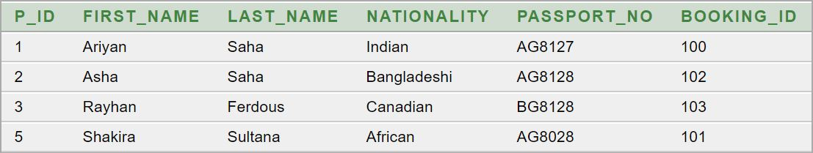

Passenger _1:

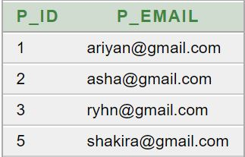

Booking:

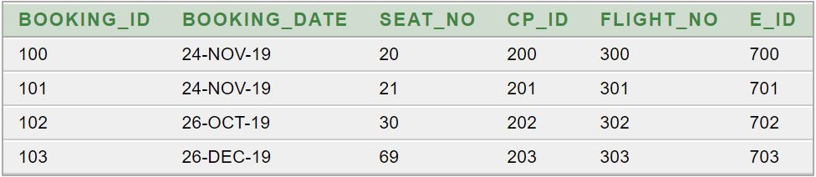

Booking_1:

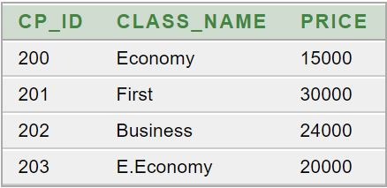

Flight: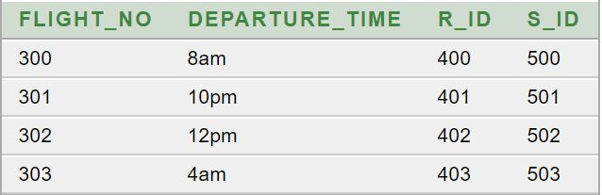

Flight_1: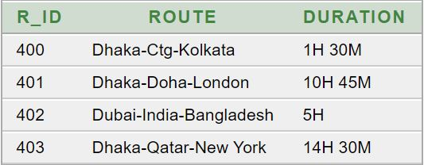

Flight_2: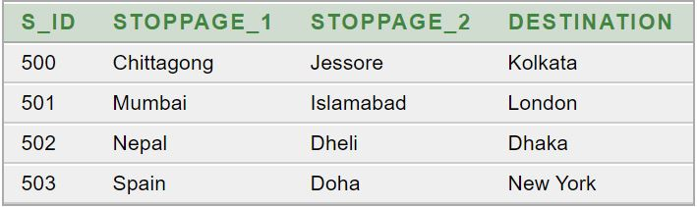

Airplane:

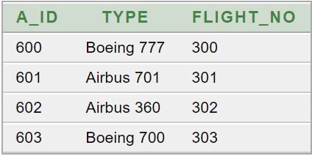

Management:

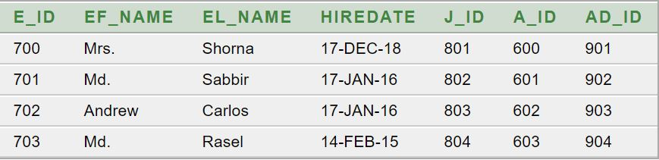

Management_1:

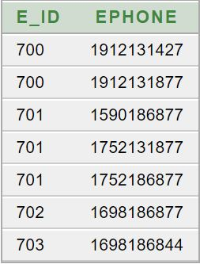

Management_2:

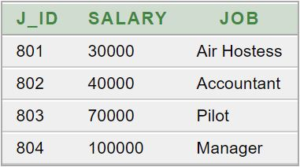

Address: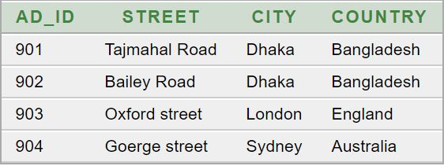

**Constraint:**

Passenger:

1. Here passport_no is unique constraint.
2. first_name have not null constraint.
3. Last_name have not null constraint.
4. Nationality is default ‘Bangladeshi’.

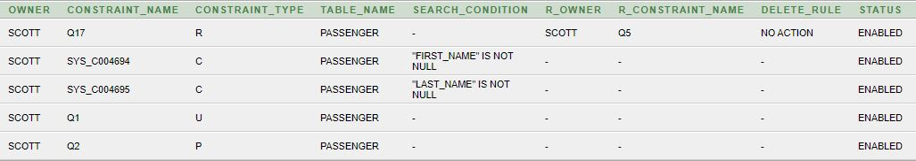

Passenger_1:



Booking:

1. Seat_no is unique.

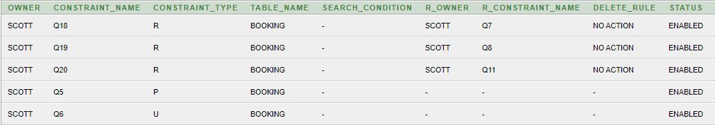

Booking_1:

1. Class_name is not null.
2. Price is not null.

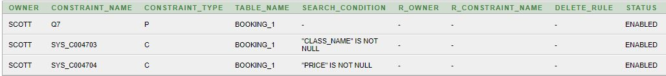

Flight:

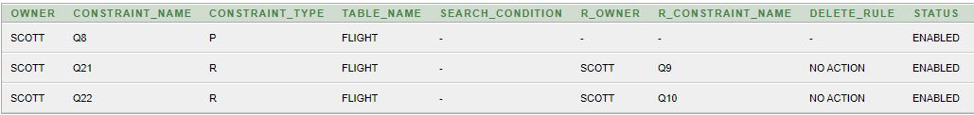

Flight_1:



Flight_2:

1. Destination is not null.



Airplane:

1. Flight_no is not null.

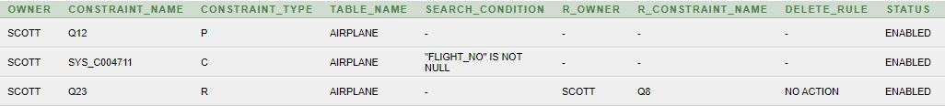

Management:

1. Hiredate is not null.

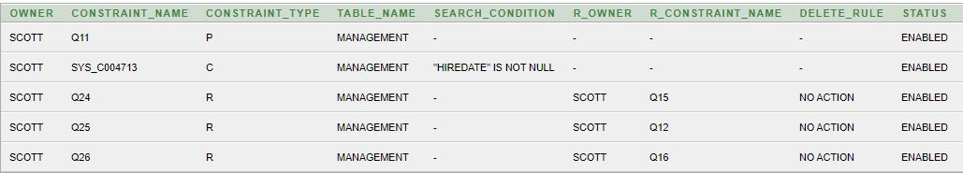Management_1:



Management_2: 

Address: 

**Constraint Enable & Disable:**

Here in passenger table unique constraint for passport_no is disabled and last_ name not null constraint is also disabled.

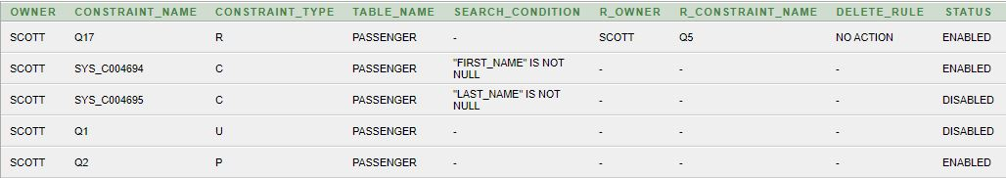

Now we, will try to insert some values which are not unique in passport_no column and also insert null value in last_name column.



Now,we can insert values that are not unique and also null values,

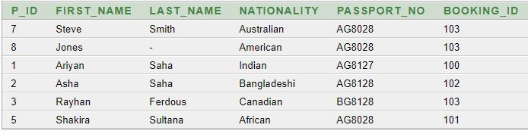

**Query question:**

1. Find the employee name and salary who earns highest amount of salary.

2. Show all the phone numbers of the employee whose last name is Sabbir.

3. what is the nationality of the passenger whose name is first name is Shakira.

4.Show the seat no, class name,price flight no of the passenger whose name is first name is Ariyan.

5.Create a view named “view_1” for showing all the class name and price of the class and rename class name to “class” from table booking_1.

6.Display route and duration of flight number 303.

7.Find the employee’s first name and last name who were hired between '12-MAR-15' and current date.

8.Show the names of the employee whose city is “Dhaka”.

9.Find the job ID for each job of an employee whose salary greater than 50000.

10.Find the employee name whose name start with ‘C’ and 4th word is ‘l’ and finish with ‘s’.

**Relational Algebra:**

1. what is the nationality of the passenger whose name is first name is Shakira.
2. Show the names of the employee whose city is “Dhaka”.
3. Find the job ID for each job of an employee whose salary greater than 50000.
4. Show all the phone numbers of the employee whose last name is Sabbir.
5. Display route and duration of flight number 303.